Fire-Proof Steel Roller Shutter |  | 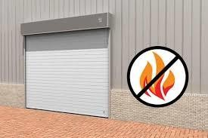
Door type | Fire Rated Rolling Shutter |  | PL. indicate your requirement
Dimensions | EW 60, E 60 - Width: 1000 – 2500 mm  Height: 1000 – 2450 mm  EW 45,EW 30- Width: 1000 – 6000 mm  Height: 1000 – 6000 mm
Surface: | Galvanized steel
Shutter curtain | Consisting of hinge-like interconnected galvanized steel profiles
Profile | Double-skinned 1 mm galvanized steel, filled with mineral wool
Bottom seal retainer: | Double-skinned box profile made of galvanized steel L-shaped profiles and C-shaped profiles (23 x 8) mm with rubber seal
Guide rails: | Galvanized steel profiles 2.5 mm (82 x 110 mm) with wear-proof guides
Winding shaft | Prime-coated steel tube in accordance with DIN 2458 with shafts welded onto each side for drive, anti-drop device or bearing support
Header seal | Standard
Consoles | Made of 4 mm thick sheet steel
Drives and controls | Direct mount drive with integrated anti-drop device or chain drive with separate anti-drop device.

